Developing Resilience

Skills that this session will develop:
Attitude - Staying Positive
By the end of this session the mentee will be able to:
- Explain what resilience is
- Describe the different steps they can take to become more resilient

Session Preparation:
- Mentee and mentor to both think about an example of when they have demonstrated resilience and be prepared to discuss these examples in the session.
- Mentee to complete Wheel of Life activity before session (pages 3-4).

Session Plan:
Review the information below and then complete the tasks together.

Resilience is the ability to stay balanced, adapt and bounce back quickly from setbacks and adversity. When things don’t go as planned, resilient people acknowledge the situation, stay committed and increase their efforts to move forward.

Anyone can improve their resilience through effective awareness and action. A key aspect of being resilient is knowing that although you may not be able to change the environment around you, you can change how you choose to let it affect you.

You can develop resilience in several ways. For example, you can:
- Look after your physical health:
Try to exercise regularly and get enough sleep, so that you can control stress more easily. The stronger you feel physically and emotionally, the easier it is for you to overcome challenges.

- Give yourself a break:
Reward yourself for achievements – even small things like finishing a piece of work or making a decision. Take a break from your normal routine to help you relax and feel refreshed.

- Build your support network:
Build strong relationships with family and friends, so that you have a support network to fall back on. Sometimes just telling the people close to you how you're feeling can make a big difference – and they might be able to help you out in other ways too.

- Make some lifestyle changes:
Focus on thinking positively, and try to learn from the mistakes you make. Set specific and achievable personal goals that match your values, and work on building your self-confidence. Remember that despite the setbacks or stresses you may face, you will become stronger and succeed eventually.

For more information on how you can strengthen these aspects, as well as build resilience in other ways, please see here.

Task 1: Share with each other examples of when you have demonstrated resilience. Discuss what you found difficult about the situation and how you managed to overcome it.

Task 2: Review the mentee’s Wheel of Life (page 4). Together, discuss the following:
- Identify which categories the mentee is most satisfied in and least satisfied in. Ask the mentee to describe what is making them satisfied. For their least satisfied categories, work together to think about how the mentee can go about changing that.
- Complete the action plan (page 5). Set the mentee time frames to complete this in and come back together after to see how they are progressing.

For more information on developing resilience:
https://www.mindtools.com/pages/article/resilience.htm
https://ideas.ted.com/8-tips-to-help-you-become-more-resilient/
https://youngminds.org.uk/find-help/looking-after-yourself/

Wheel of Life Activity

The Wheel of Life is a model used to provide a visual representation of different areas of your life. In completing the activity, you will be able to consider each category in turn and assess where you are spending your time, what’s making you happy, and what's off balance.

The Wheel of Life is something that can be revisited regularly. You can quickly draw up a wheel of life every 3-6 months to see how you are progressing.

How to complete the activity:
- Use the questions provided below to help you think through how satisfied you are in each category of your life.
- Consider each category in turn, and on a scale of 0 (low satisfaction) – to 10 (high satisfaction), plot your scores on the wheel (page 4).
- Now join up the marks around the circle. Does your life wheel look and feel balanced? You will discuss this with your mentor in the session.

Questions for each category:

Community and Volunteering  • Do you feel like you are in a good community?  • Do you feel involved in your community?  • How would others rate your contribution to society or to them as individuals? | Home and Environment  • Are you comfortable with the home that you live in?  • Do you have a clean and tidy environment?  • Do you have space for yourself?
Fun and Leisure  • Are you enjoying life and making it fun?  • Do you socialise often?  • Do you regularly do what you love? | Health and Wellbeing  • How physically healthy are you?  • Are you satisfied with your level of fitness?  • Do you feel content?
Professional Development  • Are you satisfied with your level of professional development?  • Do you feel confident with your skillset?  • Are you making good progress with your career aspirations? | Education and Learning  • Are you where you want to be right now?  • Do you feel prepared for the next stage of your education?  • Do you feel supported by your learning environment?
Self-esteem and Personal Growth  • Do you appreciate yourself?  • Are you satisfied with your direction in life?  • Are you trying new experiences and thriving to learn? | Family and Friends  • Is your family supportive of you?  • Are your friends supportive of you?  • Do you see your friends and family often?  • Are you supportive of your family and friends?

Wheel of Life
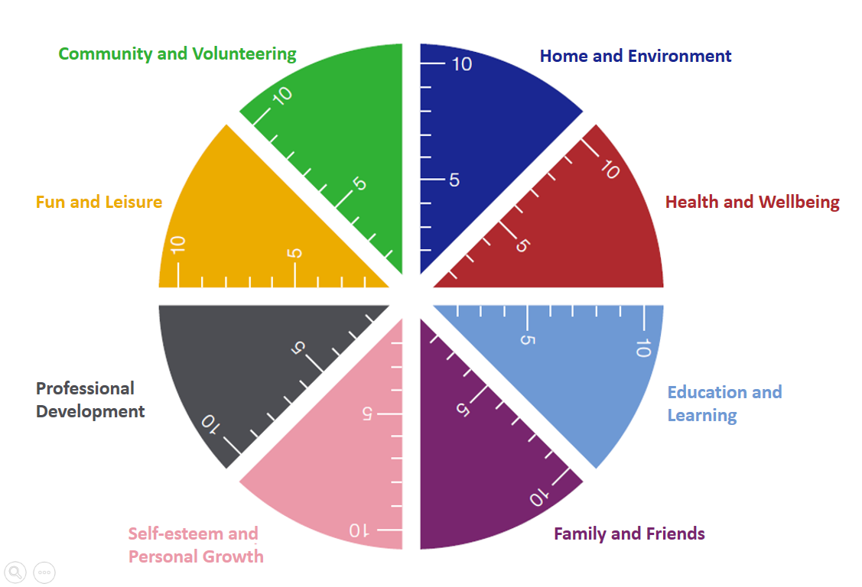

My Action Plan

Write your key goals or objectives based on your 3 lowest scoring categories on your wheel of life. These could be as big as setting out a plan for the next step in your professional development, or as small as calling a friend more regularly.

To get you started, go for a quick win and choose something small and simple. Those small things will add up and in turn you’ll be building your resilience!

1.

I will achieve this by (date):

2.

I will achieve this by (date):

3.

I will achieve this by (date):

